Level Money

Team Members

|  |  |
| --- | --- |
| **Name** | **Username** |
| Николай Раденков | radenkov |
| Адриан Божанков | Adrian.bozhankov |
| Георги Малковски | malkie |
| Любомир Свиленов | LSvilenov |
| Рени Гецкова | geckova |
| Димитър Джуренов | dsd321 |
| Светозар Керчев | Zarko91 |
| Иван Иванов | zdzdz |
| Нико Ройд | nico.broun.988 |

Description

Our application calculates user’s incomes and expenses. User input sums which he earns and spends. Application saves this input in text file and when user want statistics about his transactions, the application calculates and visualized information.

Class Diagram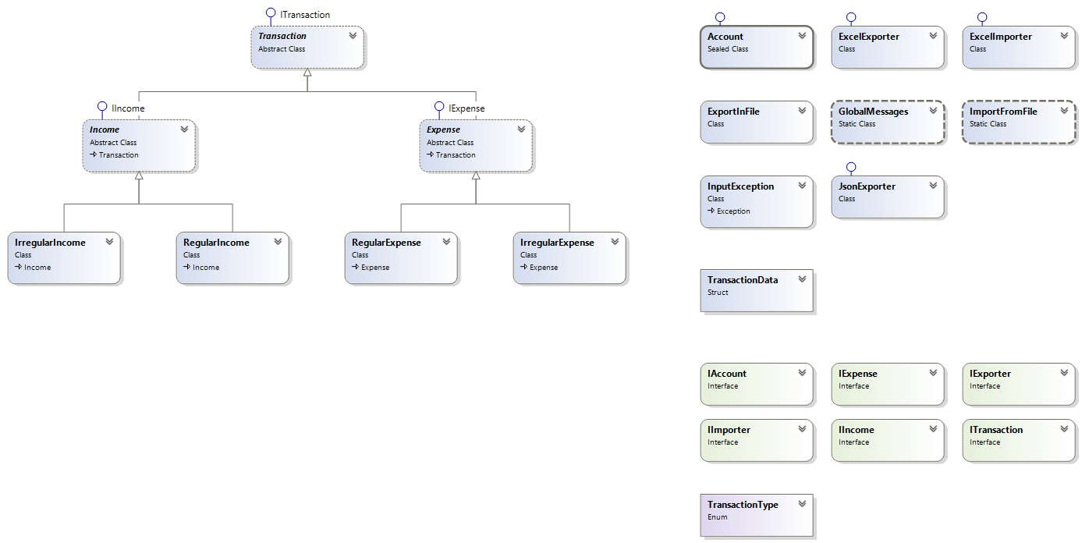

URL of Git repository

https://github.com/DimitarSD/ElderberryTeam